Jeb Luke, Joshua Kapusana, Otis Graetz, Joel Pita, Simwinji Sayowa, Some Other Guys

Contract

Dumbo Engineering

Contents

Scope of Work 2

Work Space and Parameters: 2

Agreed Outcomes 2

Timeline 2

Budget 2

Close Out 2

# Scope of Work

Convert the given lathe from manual to CNC (Computer Numeric Control). Stepper motors and ball screws will be used to drive the X and Z axes. The machine will be covered for safety reasons. The tailstock will remain manual for drilling. Inductive sensors will be used for detection. Oil and/or water will be used as coolant.

The tool post will also be automated at a later stage.

## Work Space and Parameters:

* 550 mm length
* 210 mm diameter
* 22 – 1800 RPM
* 0.05 – 0.4 mm/rev feed rate

# Agreed Outcomes

* The lathe will function as CNC at the end of the first stage of the project.
* The lathe will be drawn up in Inventor to represent the final state of the lathe.
* The current feed and lead screws with be replaced with ball screws.

# Timeline

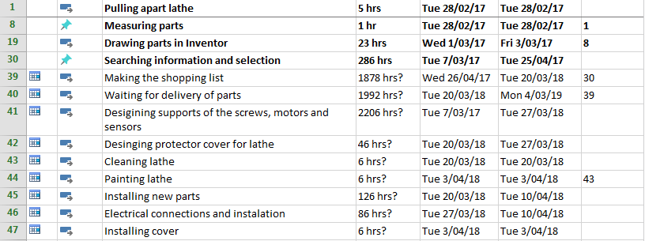

# Budget

$10190.99 (Cost already drawn up in Excel)

# Close Out

Produce a complete set of drawings and a project report able to be read by other engineers.

Student Signature Lecturer Signature